

Group Project

Mid Semester Progress Report – Group 19



Xi Leer (u3169006), Guangwei Luan(u3105172), Tenzin Dendup (u3149399), Dongge Wang (u3183663)

Contents

Executive Summary 3

Updated Project Scope, Timeline and Plan 4

Project Status Update 5

Updated Risk Assessment and Management Plan 6

Configuration and Change Management Plan 6

Appendix 1 – Some Proof of Progress Made 7

Appendix 2 – Updated Risk Assessment & Management Plan 8

# Executive Summary

Our group (Group 19) is working on developing a website that features Five Places of Interest in Canberra. These five places are some of the main places of tourist attraction and showcases various aspect of life in Canberra. These places are of interest in terms of nature, wildlife, politics and history of Canberra and Australia in general. The website aims to function as a one-stop place from where people, and particularly tourists, can get a broad overview of places to visit. The group considers having the website hosted on a public webserver as our key success criteria.

To implement this website, the group decided to use ASP.NET Core Web Application developed in Visual studio as the primary development and build environment.

An updated version of project plan and schedule with proper task breakdown and project risk management plan has been developed to amend some of the aspects that was overlooked in the initial plan. In addition, an updated risk assessment and management plan has also been developed.

As of the writing of this report, the group has finished designing the prototype for the website. Initial coding to implement the home page has started. The group intends to implement the scope incrementally, with tests carried out wherever necessary. The group has also created a free Amazon Web Services (AWS) Educate account which will be used to create a webserver on which the website will be hosted. Having a registered domain name for the website is currently out of the scope.

The group has decided not to use any version control tools since none of the group members have any experience in using them and we did not want to subject our schedule to stress by spending time learning them. In its place, we have decided to make regular backups of working code to Microsoft drive using our university email id. The group also uses Microsoft drive to work on reports and presentations collaboratively. We also use a shared document to keep track of changes and decisions.

# Updated Project Scope, Timeline and Plan

The group is developing a website to showcase five places of tourist attraction in Canberra. These places are of interest in terms of nature, wildlife, politics and history of Canberra and Australia in general. The group has chosen National Arboretum, Canberra Zoo, Parliament House, War Memorial and Telstra Tower as the five places.

In the initial project plan, the group overlooked some aspects of the project, which will be highlighted here. The group initially wanted to work on a website on restaurants in Canberra. We later found out that two of the group members are taking a unit on Web Development and the assignment in that unit is to develop a website on restaurants in Canberra. To avoid conflicts and other academic issues, the group decided to change the project topic to develop a website on five tourists spots in Canberra. Besides, the group also overlooked task breakdown and ended up with a schedule where the entire development or coding phase was shown as a single task spanning 3 to 4 weeks of work. We have also missed some of the scope and did not include mid-semester and final report and presentations in the task breakdown and schedule. These shortcomings became apparent when the group started working on the project.

In the updated task breakdown and schedule, we have included two additional scope items (user comments and deployment to public server), added schedule for report and presentation preparation and reflected a better breakdown of tasks so that we can develop the website incrementally. The updated scope of the group project is listed below:

1. Home page to give an overview of the five places
2. A webpage for each place containing
   1. A brief description
   2. Location using google map
   3. Link to their actual website
   4. A picture gallery
   5. Ability for the user to post comments and view comments already made by others
3. The website hosted on a public server
4. Documentation on deployment of the website

As a website which primarily provides information without too much background processing, our testing processes are relatively simple for the initial increments and includes checking that the links work. More testing will be involved when we develop the google maps and commenting feature. All tests will be carried our incrementally as the features are developed.

The updated task breakdown and schedule is shown in the figure below and all progress updates in this report are based on this updated project plan.

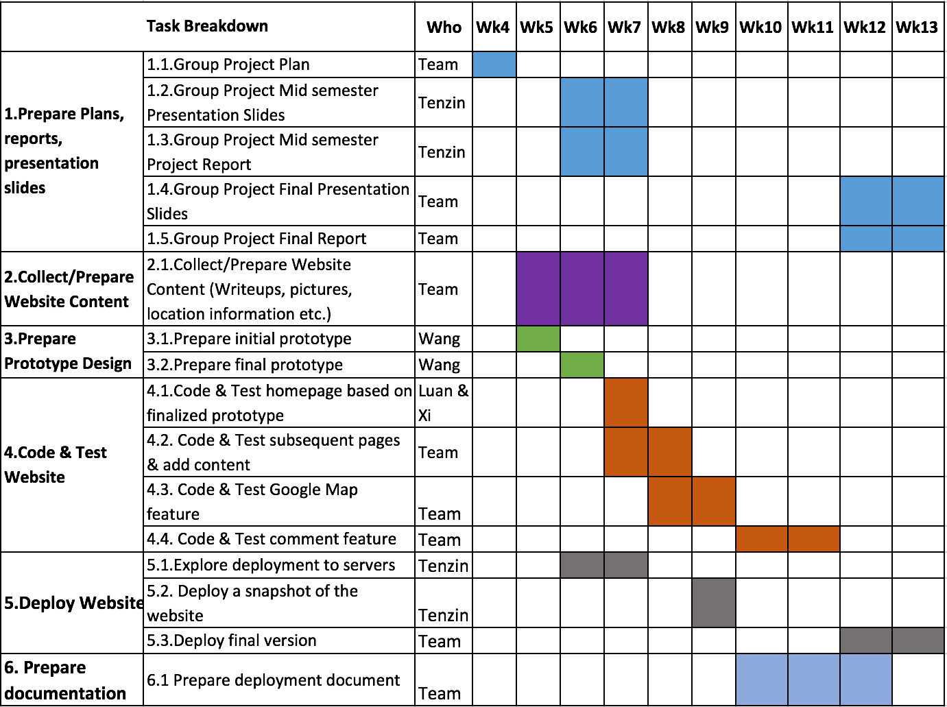

*Figure: Task breakdown and schedule for Group Project*

# Project Status Update

In view of the limited programming experiences of the group members, the group has been careful in scoping the project. Our scheduling reflects that the majority of the project time will be spend on developing features like location mapping based on google maps and the ability for users to make and view comments. Finding and preparing a deployment server was also deemed as a major task and hence it is started parallel to other tasks.

As of writing this report, the group has finished designing the prototype of web pages, started coding the homepages based on the agreed design, and has identified a free cloud service, Amazon Web Service (AWS) Educate, as a potential public server to deploy the website on. A free AWS Educate account is set up and we have been able to get a server instance running with a global IP address. These activities have progressed as per the update schedule.

In terms of preparing the content, while the written content is done, there is a possibility that collecting all the required pictures may take a little longer than planned. This is primarily due to the assumptions that the group will be able to acquire the required pictures from the internet. But we found out that it would take more effort to find pictures with proper reuse license. The group will need to visit the five places and take the required pictures.

Till now the group has had three group meetings during which the members discuss issues and do the majority of the group work.

# Updated Risk Assessment and Management Plan

In the initial project plan, our risk assessment and management plan has been more generic and included risks which are not directly related to the group project. As we started implementing the project, risks became more apparent and hence we have updated our risk management plan.

One risk that we have anticipated from the beginning is the risk of not finding a time for group meetings that would suit all the four members. The group therefore decided conducts meetings on weekends. A summary of the updated risk assessment and management strategy is given in Appendix 2.

# Configuration and Change Management Plan

In terms of configuration management, the group decided not to use any version control because none of the team members have much experience using it. In its place we will take regular backups of working code snapshots. To manage and track changes, the team will use a shared document to capture any changes and decisions made during team meetings. One of the main difficulties faced by the team is finding a proper time for team meeting and group work since all team members are full time students. To overcome this, the group conducts meetings and other group works on weekends. The group uses email and group instant messaging as means of communication.

# Appendix 1 – Some Proof of Progress Made

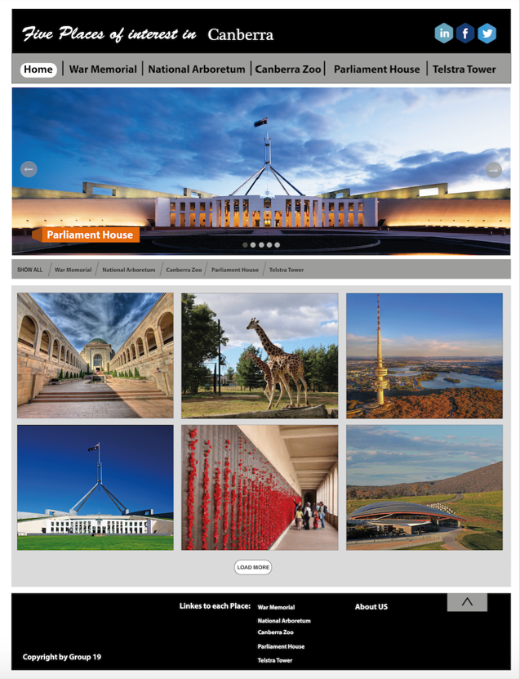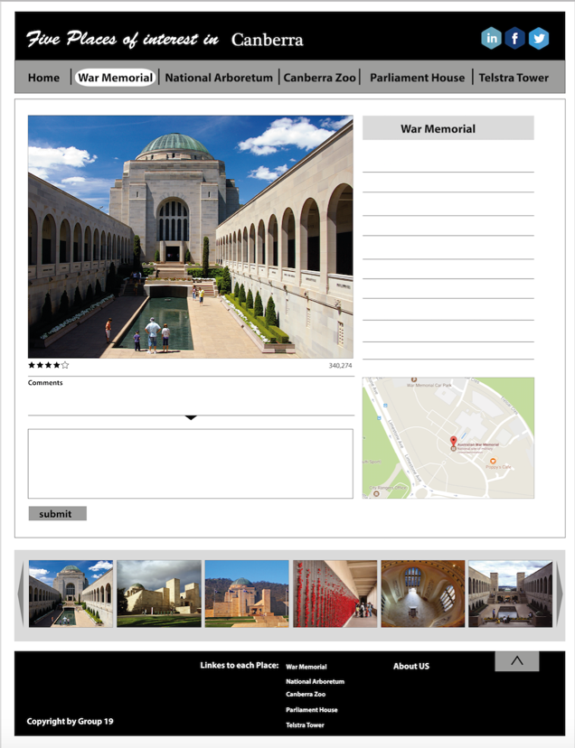

*Figure 1: Prototype Design for Web Pages*

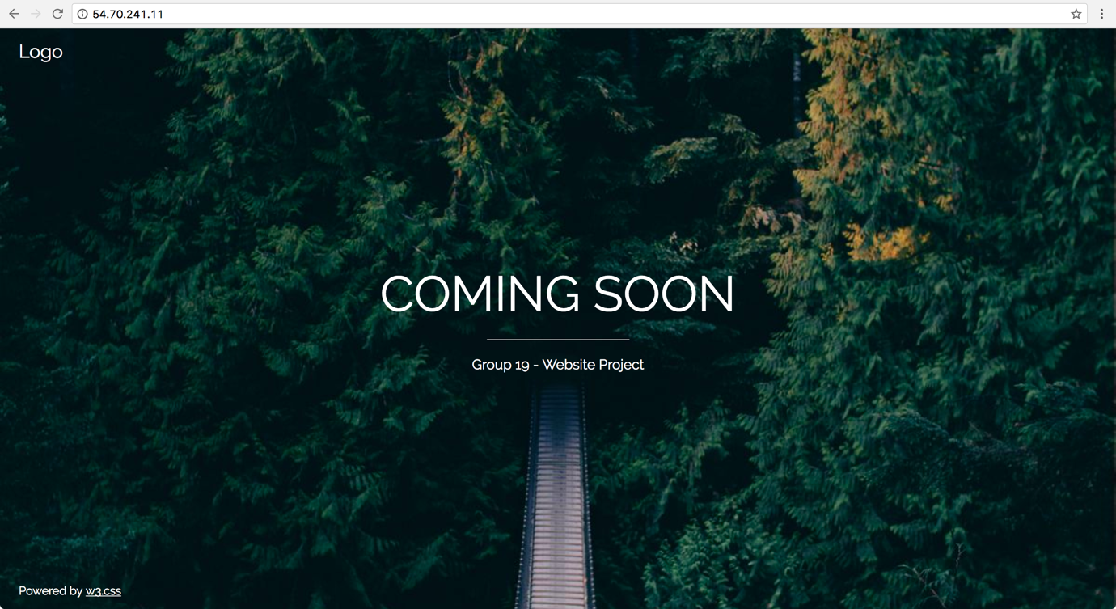

*Figure 2: Website placeholder on AWS virtual server with public IP*

# Appendix 2 – Updated Risk Assessment & Management Plan

|  |  |  |  |
| --- | --- | --- | --- |
| **Likelihood of Occurrence** | | **Severity of Consequence** | |
| ***Likelihood*** | ***Description*** | ***Consequence*** | ***Description*** |
| **A**  Rare / Highly Unlikely | Would only occur in extreme circumstances. Is not commonly seen in projects of this nature. | **I**  Insignificant / Negligible | Very low consequence. Minor disruption to workload/processes. |
| **B**  Possible / Occasionally | Can be expected but is infrequent. | **II**  Moderate | Causes moderation disruption to workload/process/deliverables. Requires careful management and actions to resolve issue(s). |
| **C**  Almost Certain / High Likely | Is expected and occurs on a regular basis in projects of this nature. | **III**  Catastrophic | Severe disruption to workflows and deliverables resulting in incomplete project and requiring intervention to rectify issue(s). |

*Table 1 - Risk likelihood vs. consequence definitions*

| **Step Three – Risk Level** | |
| --- | --- |
| ***Level*** | ***Approach*** |
| **H**  High | Urgent action required. Escalate to supervisor and/or course coordinator to devise risk mitigation/removal. |
| **M**  Medium | Requires action but there may not be an immediate risk. Log and track carefully. Devise contingency plan. |
| **L**  Low | Either manage through risk mitigation or acceptance. Continue to monitor and review periodically. |

*Table 2 - Risk Level definitions*

| **#** | **Description** | **Likelihood** | **Consequence** | **Risk Level** | **Strategies** |
| --- | --- | --- | --- | --- | --- |
| 1 | Team lack skillset required to complete project requirements | B | III | H | Ensure project team are assigned roles which are within scope of skills from the onset.  Team members to learn skills which are required by the project project. |
| 2 | Limited communication on class. | C | III | H | Timing for group meeting and group work  Meet on weekends and use group Instant Messaging for communication |
| 3 | Project plan changed from Initial Plan | c | III | H | Discuss new plan for our project, and confirm all changes from initial plan.  Re-division of each person's task. |
| 4 | Not get pictures with appropriate license | B | II | M | Groups members to visit the places and take pictures by themselves. |
| 5 | Group member going abroad for emergency | C | II | M | Use our communication channel when member go abroad.  Inform other team members early and make arrangements handover task to other team members. |
| 6 | Deployment to server may not work | B | III | H | Change scope  Identified where the problem is and arrange to deployment on other server. |
| 7 | Accidental loss of project work | A | II | M | Making regular backup. |

*Table 3 - Risk register and Strategies*